

Downstream & Chemicals

Americas Products

Safe Work Practice Standard

|  |
| --- |
| ESH 504 Vacuum Truck and Vacuum System Operation |

Table of Contents

1.0 Purpose, Objectives and Scope 5

1.1 Purpose 5

1.2 Objective 5

1.3 Scope 5

1.4 Use 5

2.0 Terms and Definitions 6

3.0 Roles, Responsibilities and Training Requirements 7

3.1 Roles and Responsibilities 7

3.2 Training Requirements 10

4.0 Standard Instructions 10

4.1 Service Request 10

4.2 Vacuum Truck Essentials Checklist 11

4.3 Verified Grounding 11

4.4 Gas Testing 12

4.5 Permit Package Requirements 12

4.6 Vacuum Truck Requirements 12

4.7 Rotary Lobe Vacuum Truck Requirements 13

4.8 Job Site Equipment Set Up for Flammable or Combustible Material 14

5.0 Records 15

6.0 References 17

7.0 Other Guidance Documents 18

8.0 Revision History 18

Appendix A: Basic Vacuum Truck Requirements 20

Appendix B: Example of Liquid Vacuum Truck Request Form or Essentials Checklist 21

Appendix C: Types of Vacuuming 22

Appendix D: Vacuum Truck Essentials Checklist Decision Logic 24

Appendix E: Approved Equipment 25

Purpose, Objectives and Scope

## Purpose

The purpose of the Americas Products (AP) Vacuum Truck and Vacuum System Operation Safe Work Practice Standard is to protect personnel, the environment and the facility by specifying the minimum requirements for safe vacuum truck and vacuum system operations within Chevron-operated facilities.

Any deviations to the Standard require management of change (MOC), including a hazard assessment.

## Objective

This document is intended to highlight the safety precautions required for carrying out vacuum truck and vacuum system activities. The document should be used in conjunction with the relevant service provider’s safe operating procedures, industry standards and established risk mitigation practices. In cases where this Standard is different from governing regulations or codes, the more stringent of the two standards or regulations will apply.

## Scope

The scope of this Standard includes the movement of materials in non-permanent systems such as vacuum trucks in the following services or areas:

* Flammable liquid service
* Combustible liquid service where the combustibles are within 15° F (8.3° C) of their flash point
* Combustible liquid service in a hazardous (classified) area
* Rotary lobe (solids or dry materials and sludge) vacuum trucks in any area
* Vacuum systems used to move materials that have the potential for containing flammable hydrocarbons or combustible hydrocarbons within 15° F (8.3° C) of their flash point

This standard does not address:

* The use or requirements of trucks used in the service of portable toilets and similar sanitary containments.
* Engineered, fixed systems involving the use of vacuum
* Other material transfer operations using other methods

## Use

Vacuum trucks should be used for the collection and transfer of hazardous materials only after other safer means have been considered.

# Terms and Definitions

| Term | Acronym | Definition |
| --- | --- | --- |
| API | API | American Petroleum Institute |
| Bonding |  | Providing electrical connections between isolated conductive parts of a system to equalize their electrical potential (voltage). Electrical resistance between two directly bonded connections should not exceed 10 ohms. |
| CFM | CFM | Cubic feet per minute |
| Combustible Liquids |  | Liquids having a closed cup flash point at or above 140°F (NFPA 30). Examples of combustible liquids are diesel, kerosene, fuel oil and vacuum gas oil. |
| Core Fleet Trucks |  | The number of trucks that are routinely used at a facility and are specified by the contract as needing to meet the higher equipment safety standard of a core truck. Vacuum trucks that will be regularly used for more than 4 weeks during a year should be considered for Core Fleet designation. |
| Diesel Runaway |  | Diesel engine “runaway” or “dieseling” will occur if high concentrations of flammable vapors enter the diesel engine air intake. Runaway can lead to destruction of the engine or fire/explosion if the engine is not quickly shut down. |
| DOT | DOT | U.S. Department of Transportation |
| Flammable Liquids |  | Liquids having a closed cup flash point below 140° F and a Reid vapor pressure that does not exceed 40 psia (NFPA 30). Examples of flammable liquids are finished grades of gasoline, aviation gasoline, naphtha and crude oil. |
| Grounding |  | Providing a means for electrical continuity so currents can dissipate to ground (earth). An electrical resistance of <1000 ohms should be achieved from the ground point to earth. Avoid using process piping, electric motor ground cables, staging, portable walkways and electrical conduit as ground points. |
| Hazardous Materials |  | Materials that are or have the potential to be flammable, combustible, toxic, corrosive or reactive. Handling this type of materials typically require precautionary measures (procedures, equipment, training, etc.). Examples include gasoline, diesel, crude oil, slop oil, acid and caustic. |
| Non Hazardous Material |  | Materials that are not flammable, combustible, toxic, corrosive or reactive. Examples include water, sewage (septic materials) and dirt. |
| Process Fluids and Chemicals |  | Any products, bi-products from, or other materials having been directly involved in a hydrocarbon or chemical process or process unit/plant. |
| Reid Vapor Pressure | RVP | A measure of the volatility of a fuel as measured at 100° F in controlled lab conditions. |
| Sanitary/Septic Sewer |  | Sewer containing wastewaters from toilets and other office sources; should not contain hydrocarbons. |
| Switch Loading |  | The practice of loading one material followed by another material with different properties (i.e. conductivity, resistivity, etc.) into a vacuum truck. |
| True Vapor Pressure | TVP | A measure of the volatility of a fuel as measured at its actual temperature. Materials loaded onto vacuum trucks must not exceed a TVP of 11. |
| Vacuum Systems |  | Portable systems used to vacuum materials in order to transfer them between locations (other than vacuum trucks) (e.g., catalyst vacuum removal equipment, spent carbon removal). |
| Vacuum Truck |  | A transportable vacuum system consisting of vacuum pump, vacuum cargo tank and associated appurtenances and accessory equipment mounted on a motor vehicle. |

# Roles, Responsibilities and Training Requirements

## Roles and Responsibilities

| Role | Responsibility |
| --- | --- |
| Chevron Company Representative (Vacuum Truck Coordinator/SME) | * Be knowledgeable of the content in this Standard and familiar with the relevant Safe Work Practices. * Provide required support documents and meet any record retention requirements. * Review Vacuum Truck Service Requests for completeness. Collaborate with Service Provider to ensure needs are understood and hazards are addressed. * Provide detailed description of material and associated hazards (i.e. SDS); coordinate additional SME support when necessary. * Work with requestor to determine disposal locations and obtain appropriate permits. * Audit field activities and conduct frequent LPOs. * Provide SME assistance to Vacuum Truck CHESM contract owners. * Be aware of and provide the means for acquiring the proper vapor mitigation equipment. * Routinely audit condition of equipment and confirm that truck operators are conducting required pre-trip and pre-job reviews. * Conduct field audits confirming that equipment is in good condition and being used correctly. * Assist contractor in finding suitable ground location when requested * Manage execution of work to enforce compliance with contract and safe work practices. * Maintain alignment with in Vacuum Truck Community of Practice. |
| Chevron Company Representative Requesting the Vacuum Truck (Terminal Manager, Head Operator, Terminal Engineer, C & M Project manager or Assistant Project Manager, C & M Manager)  Consult Safety Specialist for guidance | * Be knowledgeable of the content in this Standard and familiar with the relevant Safe Work Practices. * Provide required support documents and meet any record retention requirements. * Review Vacuum Truck Service Requests for completeness. Collaborate with Service Provider to ensure needs are understood and hazards are addressed. * Transmit form to service provider. * Provide detailed description of material and associated hazards (i.e. SDS); coordinate additional SME support when necessary. * Coordinate for disposal locations and ensure appropriate permits are obtained. * Be aware of and coordinate the means for acquiring the proper vapor mitigation equipment (consult Environmental OE/HES for regulatory requirements. * Assist contractor in finding suitable ground location when requested. |
| Chevron Contract Administrator (Procurement) | * Confirm pre-qualification requirements, including gap assessment, has been completed prior to release of contract. * Include requirements set by this Standard as part of contract requirements. |
| Contract Owner (CHESM) | * Be knowledgeable of the content in this Standard and familiar with the relevant Safe Work Practices and CHESM expectations. |
| Vacuum Truck SME  (e.g., Safety Specialist, TESH, RESH) | * Responsible for overall effectiveness of this Standard Under guidance of appropriate managerial technical authority. * Ensures DS&C Vacuum Truck Standard is kept current and incorporates changes in laws, codes, regulations industry standards, technological changes, etc. * Provides functional expertise to help work groups and facilities meet the requirements of the DS&C Vacuum Truck Standard. * Provides guidance and oversight in the approval of new vacuum truck contractors. * Provides functional expertise to help work groups and facilities minimize vacuum truck requirements for plant modifications and new plant design * Audits compliance with these standards through site visits which include; * Quality and performance reviews of active vacuum truck contractors. * Assesses competency and provides coaching to local vacuum truck SMEs and senior contractor leadership if personnel change. * Develops and communicates recommended Vacuum Truck requirements and operating procedures. * Assists with complex investigations involving Vacuum Truck operations * Annually reviews any BU approved variances to the Standard and recommends improvements. |
| Permit Issuer  (e.g., Operator or Head Operator Retail contractor having validation of required training) | Upon arrival of the vacuum truck and its operator:   * Review and verify material listed on permit matches actual material to be transferred. * Identify required Work Permits and assist in gathering necessary signatures. * Review JLA/JSA in the field with Vacuum Truck Operator, conduct appropriate permit reviews and issue permit. Associated contractors must participate in this review. * Verify Essentials Checklist has been signed by Service Provider Supervisor. * Complete required portions of the Essentials Checklist for the transfer. * Conduct reviews while work is in progress auditing equipment condition and ground verification. Monitor area for change in conditions and respond appropriately. * Understand and use stop work authority when appropriate. |
| Terminal/Project Engineering | * Support Operations/proprietor with material properties and hazard assessments for materials being transferred with vacuum trucks. |
| Qualified Verifier  (e.g., Qualified Permit Issuer, Approver) | * Review vacuum truck set up and validate that essentials safeguards outlined on the Essentials Checklist are in place prior to starting transfer. * Sign onto Essentials Checklist to confirm validation. |
| Responsible BU Manager or Supervision (For example, T&O Manager, Retail-CSI Manager) | * Reviews and approves any exceptions from these requirements. |
| Site Checker (For example, Qualified Permit Issuer, Approver) | * Conduct field audits to assure that the Essentials Checklist is being appropriately used – Document audit in Step 5 of the Essentials Checklist with a target of 10% per year. |
| Vacuum Truck Operator/Driver | * Fully understand all aspects and hazards of their planned vacuum truck operations before conducting work. * Understand and use stop work authority when appropriate. * Be current with training and know procedures for safe use of equipment. * Conduct a pre-trip and pre-job audit as well as all required equipment inspections. * Participate in and assure completion of specific pre-job JHA/ JSA’s, Essentials Checklists and permits. |
| Vacuum Truck Contractor Representative  (Service Provider manager) | * Participate in Loss Prevention Observations (LPO) as required by site. * Accountable for maintaining written procedures for safe use of equipment and emergency response. * Ensure written safety plans, JHA’s and JLA’s supporting daily activities are followed. * Provide training and certify operators are qualified for duties; maintain training records. * Maintain equipment and confirm that all devices required for safe vacuum operations are in good working order. Make repairs prior to further use. * Perform scheduled maintenance on equipment based on manufacturer’s recommendations, regulatory standards and requirements specified in this Standard; maintain maintenance records. * Supervise and audit vacuum truck operators to confirm personnel performing work are properly trained and following procedures; maintain audit records. |

Insert any additional SBU/BU language here.

## Training Requirements

### Initial Training

Service provider personnel are required to complete safe vacuum truck operation training, which consists of a classroom or computer-based training (CBT) component and a competency verification component.

The competency verification must include the following:

* For Permit Requesters, Permit Issuers and Permit Verifiers: Use and understanding of analyzers to verify proper resistance current.
* For Vacuum Truck Drivers: Equipment and operational knowledge, which must be presented to the CHESM company representative before each job.

### Refresher Training

Refresher training must be provided in in the following situations:

* When an individual demonstrates insufficient knowledge of the AP Vacuum Truck and Vacuum System Operation Standard (ESH 502).
* At least every three years.
* When an incident root cause indicates a lack of knowledge of the work permit process.

# Standard Instructions

Only service providers approved through the CHESM process by the responsible contract owners may be used for AP vacuum truck work.

Vacuum systems other than vacuum trucks used within the scope of this Standard must adhere to the following minimum requirements:

* The system must be grounded to an approved ground point with less than 1000 ohms of resistance.
* The system must have continuity through the use of conductive hoses and/or bonding systems.

Basic requirements for vacuum truck equipment are listed in Appendix A.

## Service Request

A documented Vacuum Truck Service Request or Permit must be used to communicate relevant information to the vacuum truck driver or service provider. The information may be provided using process knowledge, safety data sheets (SDS), and/or other tools such as temperature indicators and pH paper. Sampling may be required in complex scenarios. At a minimum, the Service Request must contain:

* Material name (or SDS)
* Quantity (estimated)
* Location such as plant or equipment
* Flash point
* Any other relevant hazards (For example, temperature, benzene, H2S, pH and TVP)

When relevant, the Vacuum Truck Service Request or Permit review must include, but not limited to, the following:

* Size, type and metallurgy of truck and equipment Washing requirements of truck between loads
* Exhaust management for hydrocarbon or odor mitigations Designation for offload or disposal location
* Considerations for incompatible mixtures, including hydrocarbon “switch load” concerns
* Ensure materials are not co-mingled with materials from other entities

The Vacuum Truck Service Request must first be reviewed and approved by a Chevron company representative who is requesting the vacuum truck. The Vacuum Truck Driver must receive a copy of this request that includes any special handling or procedure requirements or cautions. The Service Request must then be reviewed at the job site with the permit issuer for the site.

The Service Request information is located at the top of the Vacuum Truck Essentials Checklist.

## Vacuum Truck Essentials CheckList (ECL)

The Vacuum Truck Essentials Checklist (ECL) for either liquid or dry vacuum operations must be completed as part of the permitting process (see Appendix A and Appendix B). The ECL must be transmitted to the service provider before the vacuum truck leaves its facility. The supervisor of the service provider must sign the ECL.

ECL is used as a tool to document that the truck has the required equipment on board and the truck is in good working order. ECL is also a tool to ensure complete system continuity; from the hose end, through the vacuum truck, to the ground point.

ECLs are required for all the following:

* Flammable materials
* Combustible liquid service where the combustibles are within 15° F (8.3° C) of their flash point
* Transfer of materials in a hazardous (classified) area
* Rotary lobe (solids or dry materials and sludge) vacuum trucks in any area

ECLs must be verified by the Vacuum Truck Operator and validated by a Qualified Verifier.

## Verified Grounding

* All ground points must be verified and show a reading of <100 ohms.
* Ground verification must be performed by a Qualified Electrical Person.
* Approved portable ground verification must be performed before each use (or when the ground connection has been broken).
* Portable ground verification must be performed by a trained person using the approved equipment. (See Appendix E for AP approved equipment).

## Gas Testing

Gas testing must be performed and documented by a Qualified Gas Tester before all vacuum truck operations. Storm sumps, retail turbine sumps (water leakage only), utility sumps/vaults and car wash accumulators must read 0% LEL (lower explosive limit) for the work to proceed.

## Permit Package Requirements

A Work Permit package is required for vacuum truck operations:

* General Work Permit
* Approved JLA or JSA
* Vacuum Truck Request Form or ECL (see Section 4.2 for ECL details)Pre-Job Briefing Tool (T&O)

## Vacuum Truck Requirements

### Liquid Transfer Requirements

The following material and equipment limits apply for liquid transfers:

* Materials with 2.5 pH or less must be handled with a stainless steel truck. Hose type and fittings must also be compatible.
* Materials with a true vapor pressure (TVP) greater than 11 psia shall not be handled by a vacuum truck.

### General Requirements

The following general limits and requirements apply to all vacuum trucks:

* The Vacuum Truck Driver or Operator must remain within 25 feet (7 meters) of the truck during the transfer.
* Temperature limit must remain under 120°F (50° C) unless truck and disposal site equipment is specifically verified to accommodate higher temperatures.
* Vacuum truck must not handle pyrophoric or oxidizing materials without taking steps as required to mitigate and determine that the hazard has been neutralized.
* Vacuum trucks must not handle explosive solids such as sulfur dust.
* If a vacuum hose will be connected to process equipment, a Chevron-approved procedure must be used to prevent collapse or overpressure of vacuum truck tank or process equipment..
* For connecting to in-service equipment, an MOC or site-specific procedure must be used.
* Approval for connecting vacuum truck to equipment shall consider the necessity of a drain or vent valve on the vacuum truck piping for confirmation that the hose is safe to disconnect.
* If the vacuum exhaust might be returned to the source container, an approval must be obtained from Vacuum Truck Coordinator or subject matter expert (SME) and Engineering SME.
* If exhaust scrubbers are used, they must be rated for the vent rate.
* The vendors or providers of scrubbers and media used for exhaust scrubbers must provide a technical or engineering review for size and type recommendations, media limitations (including break-through and heat-up considerations) and cautions necessary to make informed decisions on the use of exhaust scrubbers.

### MOC Approval

BU Engineer(s) or SME shall also be consulted for first time users and participate in the MOC for approval.

* When loading materials from different locations (or a different load), ensure that materials are compatible to prevent violent reactions. Examples of materials warranting concern include, but are not limited to, the following:

Acids

Bases or caustics

Flammables or combustibles

Oxidizers or peroxides

### Connecting Vacuum Trucks to Process Equipment

* If connecting a vacuum truck to live process equipment, an approved procedure or MOC must be used. The process equipment pressure must not exceed the PSV set point on the vacuum truck.
* If connecting a vacuum truck to isolated process equipment, the residual process pressure must not exceed the PSV set point on the vacuum truck.

## Rotary Lobe Vacuum Truck Requirements

Rotary lobe (dry material) vacuum trucks are primarily designed for use in the transfer of dry materials, soil or heavy sludge that does not contain free-standing hydrocarbons. Due to the heat generated in the rotary lobe blower and areas of the transfer system, rotary lobe-equipped vacuum trucks are not permitted for use with combustible or flammable materials; or for use in a flammable environment.

### Requirements for Using Rotary Lobe Trucks

If there is a potential for pockets of low flash material to be mixed in with non-flammable material (such as contaminated soil), it is required to monitor hydrocarbon vapor or air concentrations at the pick-up point or air outlet of the vacuum truck discharge. If monitoring is done at the discharge, initial gas testing must be performed and documented. Additional gas testing may be required as determined by the Qualified Gas Tester.

* The readings must remain <5% LEL.
* If, at any time, 5% LEL is exceeded, the transfer must be shut down and operations must be notified.
* Material should be evaluated for the potential for changing conditions.
* A monitoring plan must be developed to address this hazard accordingly.
* In some non-hazardous applications, the size and weight of conductive hoses may be impractical for performing the required tasks and non-conductive hoses are permissible.
* Personnel working with dry material vacuum trucks must be protected from static discharge by either or both of the following:
* Anti-static personal protective equipment (for example, flooring, footwear, clothing and personal grounding devices).
* Conductive hoses that have been continuity tested with an ohm meter.
* Vacuum breakers or electronic emergency shutdown devices (E-Stop) must be used if a hose operator will be required.
* The Dry Vacuum Essentials Checklist must be used to verify and validate that essential safeguards are in place with each material transfer.

### Requirement for Rotary Lobe Trucks for Use in Hydrocarbon Services

Some rotary lobe vacuum trucks designed to run at high volumes are equipped with pump cooling systems, high temperature shutdowns and temperature monitoring instrumentation. These are particularly useful for large jobs such as tank cleaning operations where the presence of hydrocarbons and flammable atmospheres are likely. Approval for use of these trucks for such operations must be made using the AP MOC process with approval by the Downstream and Chemicals (DS&C) Vacuum Truck SME and DS&C Senior Safety Advisor.

## Job Site Equipment Set Up for Flammable or Combustible Material

Vacuum truck must be spotted on level ground safely away from flammable sources. The vacuum exhaust hose routed a minimum of 50 feet (15 meters) away from personnel, and downwind from the truck and other ignition sources. Trucks designed and equipped with vacuum vent stack exhausting at 12 feet (3.65 meters) above the truck’s cab are also acceptable (not approved by Chevron for still wind days).

**Note**: Properly spotting a vacuum truck away from flammable sources avoids potential ignition as well as “diesel runaway.” If runaway occurs or is suspected, shut down the truck’s engine immediately.

* All collection containers and scrubbers must be made of conductive material. Vacuum truck and equipment grounding, bonding and verifications need to follow ECL.
* All hoses must have functional connections and be double secure (pinning, banding or taping lobes).
* If during job set-up, a hose tests at >100 ohms, the Supervisor must be notified and the Driver must either replace the hose or use a circuit test (EC Option 1) with a total resistance limit of <10,000 ohms. Hose must be replaced following the transfer operation.
* For non-conductive collection areas such as concrete containment areas, sewer boxes, berm areas, ditches and drum spill containment or spill guards, the liquid vacuum truck hose must be bonded to a verified ground point.
* For tank cleaning operations conducted through manways, the open end of the hose shall be bonded to the tank being cleaned (Appendix C).
* When carbon is used in an exhaust scrubber, considerations for monitoring heat-up must be made to prevent fire. A flame arrestor must be installed upstream of the scrubber(s) when carbon media scrubbers are used.
* Use of a positive displacement pump in lieu of the truck’s vacuum pump shall be considered where exhaust hose vapors are of concern.
* Use of a positive displacement pump in lieu of the truck’s vacuum pump shall be considered, if practical, where static or fire hazards are of concern.
* Vacuum transfer operations shall minimize agitation of flammables or hydrocarbon- bearing liquids to reduce static generation by:
* Hydrocarbons and flammables shall be transferred to a truck or truck containers through the bottom line to avoid splash filling.
* Whenever possible, the vacuum hose is be submerged in the liquid. Where submersion is not possible and job duration is prolonged, the hose end must be bonded to a ground point to ensure safe dissipation of the static generated in the hose.
* Flammables and combustibles within 15° F (8.3° C) of their flash point, shall be loaded at reduced rates until the vacuum truck inlet port is well covered.
* Gravity discharge for all materials shall be used where possible. Pumping off is also a common and is a Chevron-approved practice. The use of alternative methods such as pressuring off shall only be used in accordance with thorough hazard analysis and proper safeguards for hazard mitigation.
* Pressure off-loading is prohibited for materials with an open cup flash point below 100° F (38° C). If pressurized tank discharge is required (only when the open cup flash point is above 100° F (38° C), a JSA (short-term) or MOC (long-term) showing process steps with risks and mitigations must be reviewed and approved by business unit management and Vacuum Truck SME.
* After any loading or discharge operation, the vacuum truck shall be left with grounding cable attached for five minutes to allow for dissipation of static that may have accumulated in the debris tank during the operation.

# Records

Table . Document Change History

| Date | Person | Revision | Chapter | Details |
| --- | --- | --- | --- | --- |
| March 2016 | AAKI | Rev 2 | Various | * Renumber document to ESH 502 from ESH 200 * Put SWP in 5 component model format * Removed various caution statements and boxes * Added various definitions * Added and clarified Roles and Responsibilities * Increased flash point from 100 to 140 for flammable/combustible material * Removed spill pad requirements * Added requirement of DS&C Senior Safety Advisor approval to use dry vac system on flammable solids removal * Added verified ground component at all times. * Added drawings of common operations * Added ECL flow chart * Added Vac Truck Service Request/ECL forms for Wet and Dry Vac Operations |
| June 2013 | TMLT | Rev 1 | Various | * Replace Refinery, Plant with Facility, JHA with JLA, Instruction with Procedure, Manufacturing with Americas Products, Worn with Used, |
|  |  |  | 1.7 | * Deleted Refinery Specific Language on Subject Matter Experts for Additional Information |
|  |  |  | 2.2.4.1 | * Added In Good Working Order |
|  |  |  | 2.2.4.5.1 and 2.2.4.7 | * Added and can be provided by the Terminal if available |
|  |  |  | 2.3.5. | * Added “ie ears”, Deleted tape, * Added Place the spill pads under the fittings” |
|  |  |  | 2.4.1 | * Added or air horn * Added or approved equivalent * Removed Refinery specific language on Nextel type devices |
|  |  |  | 2.5.1.2, 2.5.2.2, 3.1.3 | * Added Items are validated during HES System Review |
|  |  |  | 4.1.2.1. | * Added A tank ground cable may be sufficient, provided there’s no obvious corrosion to the ground and was installed professionally. Testing with an ohm meter down the cable from the clamp can assure the clamps contact with the ground cable and minimize issues from the ground clamp not penetrating any rust preset on the ground cable surface |
|  |  |  | 4.1.4 | * Added sequence for Figure D: * Ground Point to Truck * Hose Connect t Tank then Truck * And Figure E. Ground Point to Drum, Ground Point to Truck, Hose from Truck then to Drum |
|  |  |  | 4.3.4 | * Added Complete the Vacuum Truck Checklist with Each Permit. See Appendix D |
|  |  |  | 4.4.1.9, 4.4.1.10 | * Added May Not Apply In Americas Products. |
|  |  |  | 4.4.2.1.1 | * Added This will prevent overfilling of vacuum truck. |
|  |  |  | 4.4.2.10 | * Added Spill bucket has no plastic handles. No PVC stingers. |
|  |  |  | 4.5.4 | * Added Check temperature of carbon and perform sniff test (outlet). Make sure not to exhausting to atmosphere under a canopy or roof structure. |
|  |  |  | 4.6.1 | * Added Sequence * Hook ground cable firth and then to truck * Connect hose to grounded piping first then hook hose to vacuum truck |
|  |  |  | 4.7.2 | * Removed Refinery specific exemptions |
|  |  |  | 4.8.3 | * Added Loaded or partially loaded trucks cannot be left unattended especially overnight. |
|  |  |  | 5 | * Replace Role Area head or Area Operator Designee with Operator * Added Verify LPS and site specific training is current before allowing vacuum truck operator to perform work. Verify Safe Work Practice Training (ie General Work Permit, Gas Detection, Hot Work) is current. |
|  |  |  | Table 1 | * Delete Refinery Specific RI * Insert References to 561 Static, 534 Tank Cleaning |
|  |  |  | Appendix C | * Appendix C * MS 3046 Product Loading Sequence Chart * http://formsmanagement.chevron.com/eForms.asp?FN=MS-3046&FP=MS3046.xlsx |
|  |  |  | Appendix D | * Appendix D Vacuum Truck Checklist |

Insert any additional SBU/BU language here.

# References

The following is a complete list of the documents referenced by this procedure:

Table . List of References

| Title | File Name |
| --- | --- |
| American Petroleum Institute (API) Recommended Practice (RP):   * 505 Recommended Practice for Classification of Locations for Electrical Installations at Petroleum Facilities Classified as Class I, Zone 0, and Zone 2 * 500 Recommended Practice for Classification of Locations for Electrical Installations at Petroleum Facilities Classified as Class I, Division I and Division 2 * API 2013 Cleaning of mobile tanks in flammable or combustible service |  |
| American Petroleum Institute (API) Recommended Practice (RP): 2219 |  |
| Vacuum Truck –Job Loss Analysis |  |
| Static Electricity – Hazards and Prevention | <https://learning2.chevron.com/app/servlet/goTo?Page=CourseInfo&DirectLinkID=6283699> |

# Other Guidance Documents

Table . List of Other Guidance Documents

| Title | File/Link Name |
| --- | --- |
| DS&C Proposed Vacuum Truck SWP |  |
| ESH 507 SWP General Work Permit Standard |  |
| ESH 505 AP management of Change Guidance |  |
| AP Assessing Hazards and Managing High Risk Work |  |
| ESH 512 SWP Gas Detection |  |
| ESH 561 Static |  |

# Revision History

Table . Revision History

|  |  |  |
| --- | --- | --- |
| Description | Downstream & Chemicals | SBU <Add this column if an SBU version of the DS&C document is created.> |
| Origin Date |  | December 13, 2012 |
| Revision Date |  | March 17, 2016 |
| Next Revision Due |  | March 17, 2021 |
| Control Number | Insert document control number | ESH 504 |

Table . Amendment Details

|  |  |  |  |
| --- | --- | --- | --- |
| Date | Author | Section Number | Change Reference |
| 2-2016 | AAKI | Various | Reformat Document,  Redesign requirements specific to Vacuum Truck Operation  Removal of “recommended” and “Caution” portions  Addition of Vacuum Truck Essentials Check List and Request Form  Addition of diagrams in appendices to show the correct connection and use |
|  |  |  |  |

1. Basic Vacuum Truck Requirements

The following table lists the basic equipment required for all trucks.

Table . Basic Requirements

|  |  |
| --- | --- |
| Equipment Required | Minimum Requirement for All Trucks (Any DS&C Exceptions noted) |
| Fire Extinguisher (Liquid Vacuum Trucks Only) | 20 lb B/C (9kg DCP) dry chemical fire extinguisher that is readily accessible at all times near the rear of the vehicle.  (Acceptable if fire extinguisher is provided by the site.) |
| Bonding Cables & Clamps | Clamps shall have strong springs with sharp, pointed contacts to displace rust or paint. Types of screw-down, C-clamp design are also acceptable. |
| Grounding Verification | Ground point verification of <1000 ohms of electrical resistance requires one of the following methods:  1. Use of an MGV.  2. Use of an approved ground detection meter by a Qualified Person.  3. Testing by a Qualified Electrician.  *Trucks used exclusively for non-flammable materials outside of hazardous classified areas are exempt from this requirement.* |
| Spill Response | Business unit includes spill response in their job planning and JSA or JHA. |
| Driver Work Area Lighting | None (provided as needed by Chevron or others). |
| Liquid and Vent Hoses | Conductive liquid and vent hoses with lockable connections that are tested periodically and results are documented. Rotary lobe trucks exempted.  *Hoses used exclusively for non-flammable materials outside of hazardous classified areas are exempt from this requirement.* |
| Debris Tank Gauge (Liquid vacuum trucks only) | Working tank level gauge. |
| Warning Tape or Barricades | Site able to provide barricading and/or signage as required to secure work area. |

1. Example of Liquid Vacuum Truck Request Form or Essentials Checklist

The following images show the two sides of a Liquid Vacuum Truck Request Form.

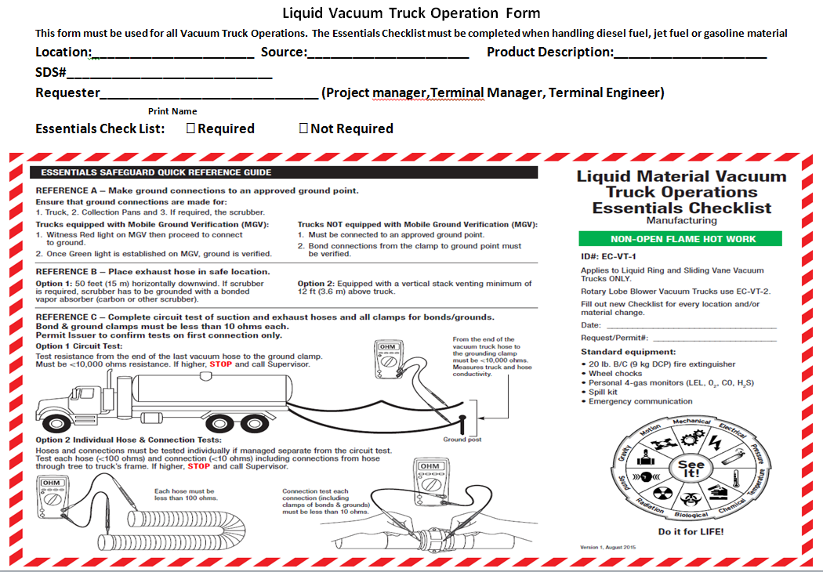

Figure . Front Side of Request Form

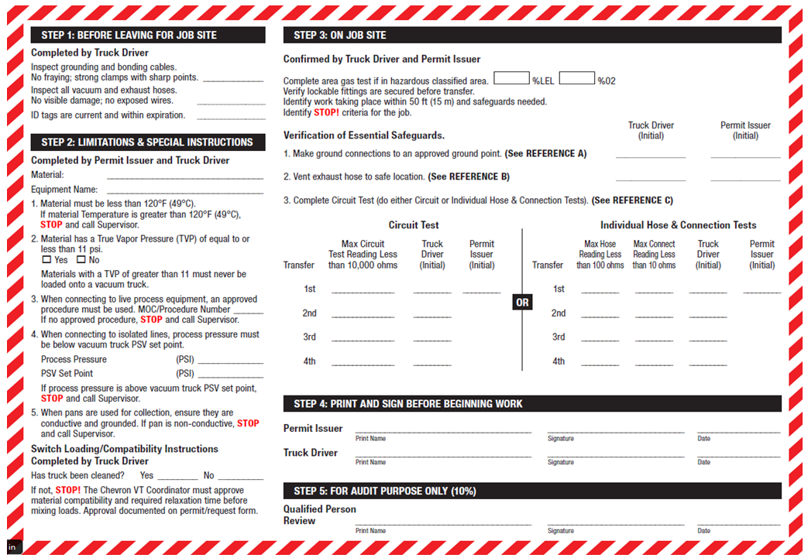

Figure . Back Side of Request Form

1. Types of Vacuuming

The following images show different types of vacuuming options.

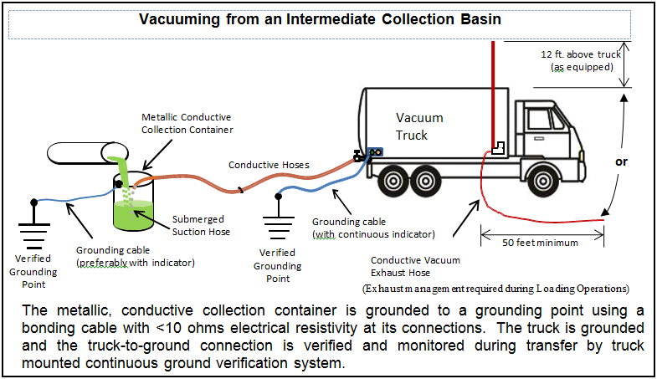

Figure . Vacuuming from an Intermediate Collection Basin

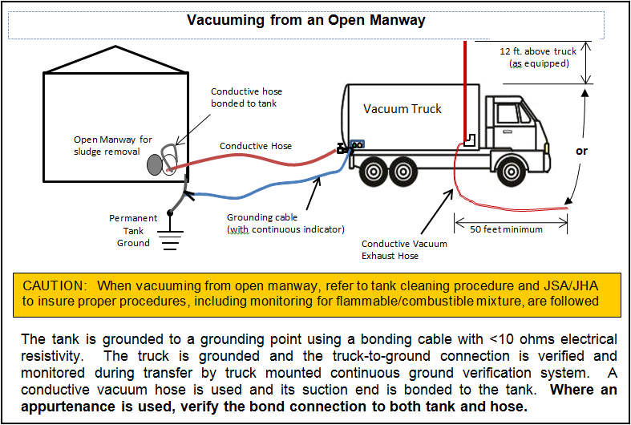

Figure . Vacuuming from an Open Manway

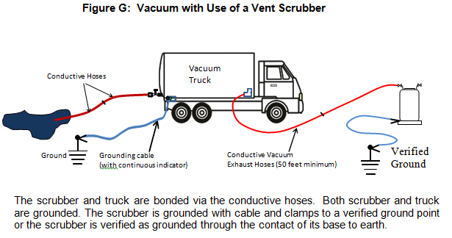

Figure . Vacuum With Use of a Vent Scrubber

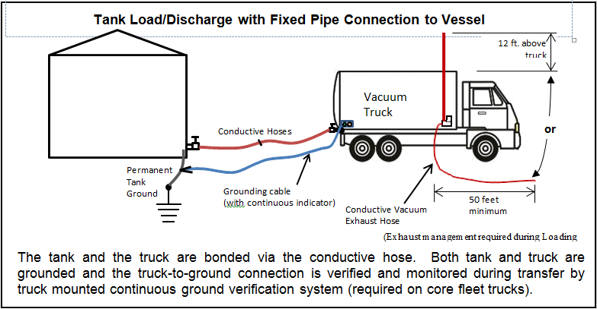

Figure . Tank Load or Discharge With Fixed Pipe Connection to Vessel

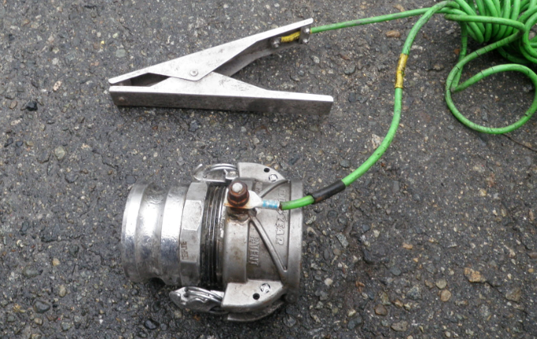

Figure . Description of a coupling with a ground/bond clamp attached

1. Vacuum Truck Essentials Checklist Decision Logic

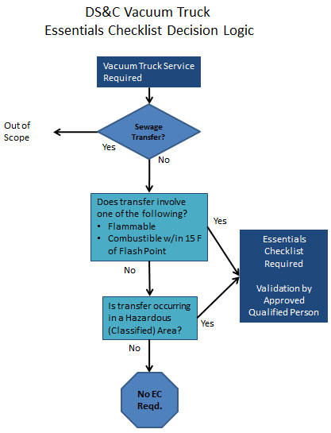

1. Approved Equipment

Using the AEMC Model 3711 Clamp-on Ground Resistance Tester

Purpose for use:

To test for electrical resistance of grounding points to be used for static dissipation from liquid transfers to or from vacuum trucks. Vacuum trucks used in Chevron’s refineries are required to use only verified ground points. Those vacuum trucks identified as part of a refinery’s core fleet are required to have a MGV (Mobile Ground Verification) device installed. Any trucks brought in to supplement needs beyond that of the core fleet may not be equipped with a MGV, but will require its grounding point(s) to be verified as having <1000 Ohms of resistance. This instruction is only intended for use to determine ground points meet the requirement as specified in the Vacuum Truck Safe Operation Standard, GR 200.

Basic Principal of the AEMC Model 3711 Operation:

The AEMC Model 3711 ground resistance tester works by sending out a specific current frequency through the test loop, (loop defined here as two ground points connected by a conductive test cable) to the ground points (see Figure 1). The signal is transmitted though the earth, picked up at the other connected ground test point and back through the cable to the AEMC device. The device picks up the current signal by a CT (current transformer) and filters out other natural earth or commercial electrical frequencies. The signal received is then converted to an Ohm reading which is displayed on its display screen. The reading is a cumulative value of resistance of the test loop (point A + Point B + the test cable). This device measures up to 1200 Ohms to one decimal.

How to use AEMC Model 3711 for Static Ground Point Determination:

**Caution -** This device is not considered intrinsically safe, so proper hot work permits (just as with the vacuum trucks) must be obtained before energizing this device in any process unit or area where volatile materials may be present.

**Step 1.** To test a ground point, two ground points are required to complete the test loop. This is accomplished by using two separate metal objects that appear to be “well earthed” (well earthed generally means the steel object is sunk well below the soil surface or into concrete) and using a conductive cable with strong, pointed steel-toothed clamps to connect the two test points (see Figure 1).

**Note – the two test points cannot be connected at all by any conductive material other than the testing cable. If the test value displayed is < 2 Ohms, recheck the test points to ensure they’re not conductively connected, or use the alternate test method below.**

Ensure that the sharp clamp points have penetrated any rust or paint on the test point.

**-Or- Alternate method for Step 1.** Two test points that are not conductively connected are required for identifying a good ground point. In refineries, piping or structural steel often connects potential ground points and assuring there is no conductive connection is often difficult. Another way to provide a test point in addition to your desired truck ground point, is to use a steel grid such as section used for refinery stair steps (see Figure 2). A steel grid/grate works best for the test in moist or muddy soil where it can be well embedded into the surface, but can be used on nearly any surface, including asphalt or concrete. Some rocky or sandy soil types may prove very difficult to get successful ground tests. Wetting harder, drier surfaces or applying weight to the grid can assist in improving the surface contact needed for successful testing of the ground planned for use. Use a conductive cable with strong, pointed steel-toothed clamps to connect the two test points (see figures 3, 4, 5). Ensure that the sharp clamp points have penetrated any rust or paint on the test point.

**Step 2.** Turn on the resistance testerby pushing and releasing the “On Off” button. A reading should display on the LCD panel as “OL .” OL indicates over limit. If it does not read Ohms, push the button under the  symbol that is located adjacent to the On Off button.

**Step 3.** Squeeze the lever on the side of the tester in to open its jaws and then place the device’s open jaws around the test cable and release the lever. The jaws must close completely without any obstruction for the tester to work properly.

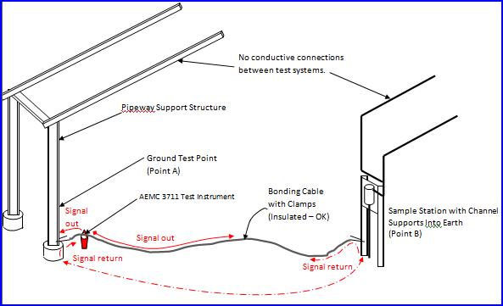

Figure . Using Two Conductive Structures Embedded in Soil or Submersed Concrete

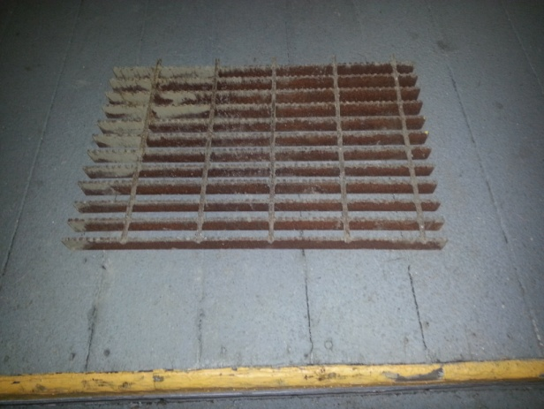

Ground test point



Figure . Test Grating – Section of Stair Step

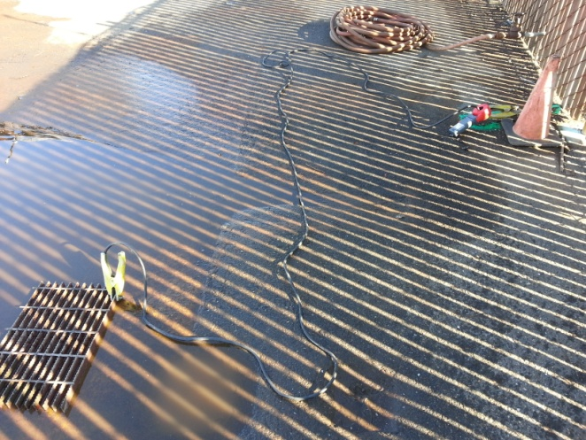

Figure . Using Test Grate on Wetted Asphalt

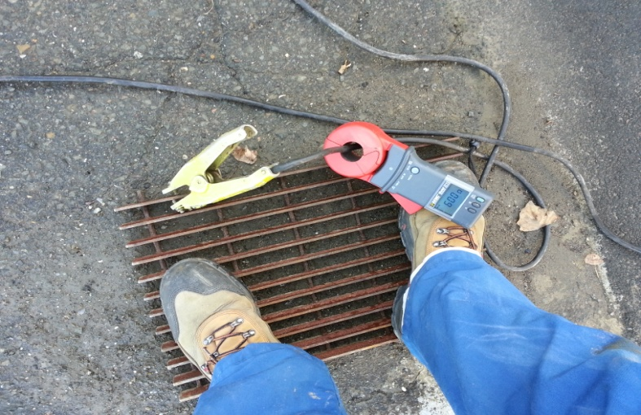

Figure . Applying Weight to Test Grate Improves Contact

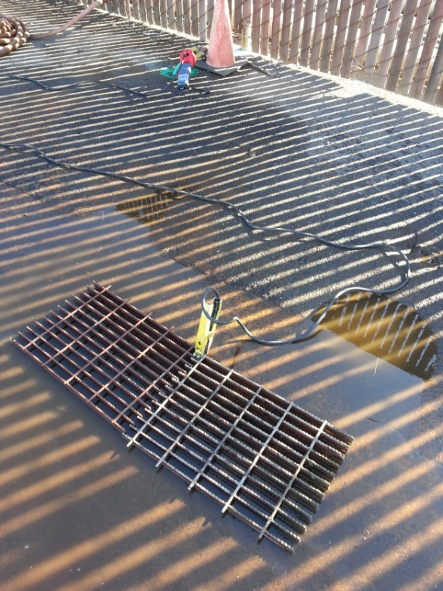

Figure . Increasing Grate Size Decreases Resistance

**CAUTION: At no time should a portable piece of grating or other such portable metal object be considered adequate for use as a ground or earthing point.**